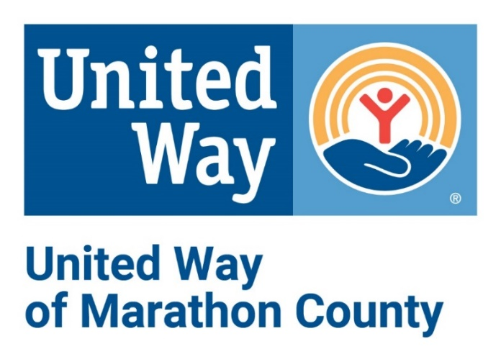

ePledge User Guide
Table of Contents
Welcome..........................................................................................................................2
Benefits of using ePledge……………………………………………………………………………………………………2
Responsibility as Administrator........................................................................................2
Setting up Your ePledge Campaign…………………………………………………………………………………….3
After the Campaign..........................................................................................................3
Sample e-mail Messages…………………………...………………………………………………………………………4
How to Access ePledge………………………………………………………………………………………………………5
ePledge Home Screen………………………………………………………………………………………………………..5
How to Make a Pledge …………………………………………………………………………………………………...6-9
Payment
Pledge options
Designating a pledge
Verification
Completed Pledge
Administrator………....................................................................................................9-14
Campaign Status
No Response Report
Transaction Report
View Reports
Employee Pledge Search
FAQs..............................................................................................................................15
ePledge Support Contact:
Natalie Cetnarowski
Resource Development Assistant
United Way of Marathon County
ncetnarowski@unitedwaymc.org
(715) 298-5710
ePledge Support Contact:
Amanda Flannery
Resource Development Director
United Way of Marathon County
aflannery@unitedwaymc.org
(715) 298-5706

For questions regarding ePledge email the support contacts above or help@unitedwaymc.org.
Welcome
ePledge is a highly secure and proven online campaign management system that provides you with the capabilities to run a successful campaign.

This campaign management tool allows you to view your company’s campaign from a dedicated, secure website, providing one central point for all campaign information.

Benefits of using ePledge
- Reduces or eliminates the need for paper pledge forms
- Maximizes efficiency of campaign administration
- Centralizes campaign information in one shared database
- Enables real-time reporting or tracking of donors throughout the organization
- Secure and confidential

Responsibilities As Administrator
As administrator for your organization, you have the ability to manage many aspects of your campaign directly through the system. The system is easy to use and intuitive, so you can quickly learn how to do the following functions so that you can act independently. The ePledge system provides the following capabilities for you to manage your campaign:
- Enter pledges for employees
- Change pledges for employees
- Delete pledges for employees
- Remove employees who have been terminated
- Run campaign reports
- Real-time reporting of campaign progress

Setting up Your ePledge Campaign
- At least 2-3 weeks prior to your campaign go to Campaign Resources - United Way of Marathon County (unitedwaymc.org) to complete the ePledge set-up request form.

- Check with your IT Department for approval for e-mails from United Way to be allowed through your security settings.

- Provide United Way with a listing (excel or csv file) of all your employees as per the fields required below: *Required
*First Name
Middle Name
*Last Name
*Work e-mail Address
Home Address
Employee ID (this makes uploading to your payroll systems easier)
Gender
Birthday
*Work Location
Number of Pay Periods
- Provide United Way with customized messaging for the kick-off and reminder e-mails.

After the Campaign
When your campaign closes, we will send a payroll file to your HR department.
Your company campaign manager should fill out the campaign report envelope with paper pledges, fully paid employees and special event money. Collect all the payments and put the money, campaign report and the cash report inside the campaign envelope you were provided.
If you are making a corporate gift, please fill out a corporate pledge card and place it in the envelope. Contact United Way to come collect your envelope or drop it off at the United Way Office located at 705 S. 24th Ave, Suite 400B, Wausau, WI.

Sample E-mail Messages:
Kick-off e-mail
Today is the beginning of the United Way campaign at Company Name and we are asking you to join the fight to improve the health, education and financial stability of every person in our community. Together, we will create a stronger, safer place for everyone.
United Way, along with their 38 partner programs at local non-profits, will use your gift to feed a hungry child, shelter an abused woman, counsel a man struggling with depression, help an elderly resident remain in their home and so much more. You will make a difference for thousands of people in our community with your gift—and a gift of $52 or more will qualify you for the 2022 Sweepstakes!

Click on this link to make your pledge. This is your personal link—please DO NOT forward this message to others.

Thank you for considering a gift to help your community thrive.
[e-mail signature block from sender block]
Sender options: Company CEO, Company Campaign Leader or UW
Reminder e-mail
Together we will fight for the Health, Education and Financial Stability of every person. When YOU give to United Way, YOU change the community for the better. Support YOUR community by giving now.
Your contribution will be invested in programs and services that meet the most pressing needs in our local community. YOU can make a difference. A gift of $52 or more annually qualifies you for the 2022 Sweepstakes.
Click here to pledge now. This is your personal link - Do NOT forward this message.
[e-mail signature block from sender block]
Sender options: Company CEO, Company Campaign Leader or UW
Closing e-mail
There are only 2 days remaining for you to participate in the 2022 United Way Campaign. The deadline for online pledging is …
Remember that when you make a contribution to United Way, you become a partner for a stronger community, helping to find long-term solutions to essential health and human service needs. A pledge of any amount will help.
When you reach out a hand to one, you influence the condition of all.
Thank you for supporting United Way.
[e-mail signature block from sender block]
Sender options: Company CEO, Company Campaign Leader or UW

How to Access ePledge
There are two ways to enter the ePledge system:
- Click on your personalized link in your ePledge e-mail.
- Enter the following URL into your browser: https://www.secure.unitedwaymc.org/crm/Start.jsp. Enter your User ID and Password.
ePledge Home Screen:
The home screen defaults to your personal donor page.
MAIN MENU
Personal link for pledging, viewing giving history and contact information.

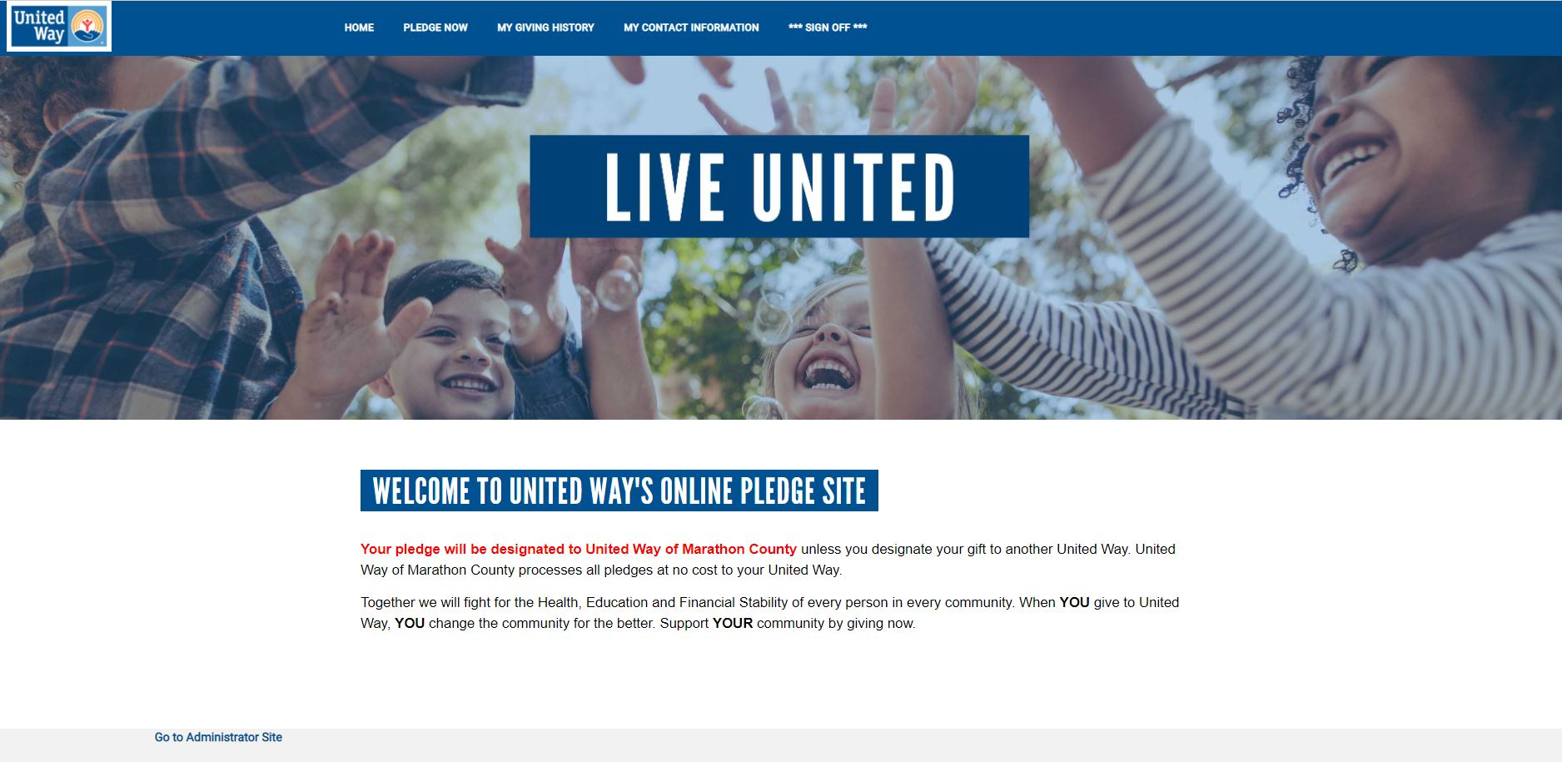
GO TO ADMINISTRATOR SITE
Switches the donor to Administrator Menu.

Things you can do from this screen:
Ready to make your gift? Click PLEDGE NOW in the main menu.
Want to view last year’s gift? Click MY GIVING HISTORY in the main menu.
Would you like to update your address? Click MY CONTACT INFORMATION in the main menu.
Ready to run campaign reports? Click GO TO ADMINISTRATOR SITE to switch to the Admin menu.

- HOW TO MAKE A PLEDGE:
Click PLEDGE NOW in the top menu to start the pledge process.

- PAYMENT:
Select your method of payment. “Credit Card”, “Payroll Deduction” or “Sorry, I don’t wish to give at this time”.
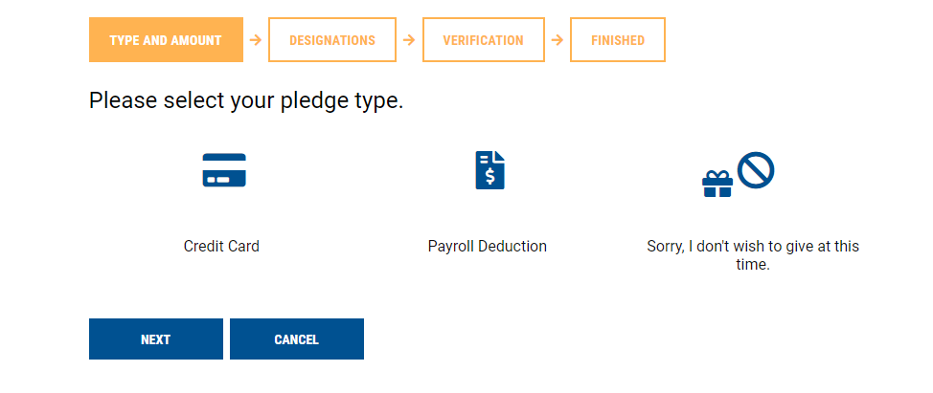

- PLEDGE OPTIONS:
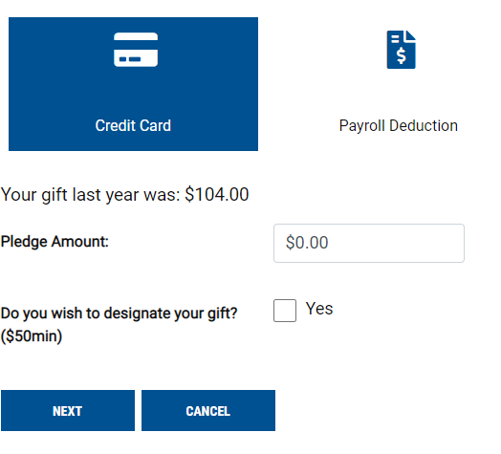
Credit Card: Payroll Deduction:
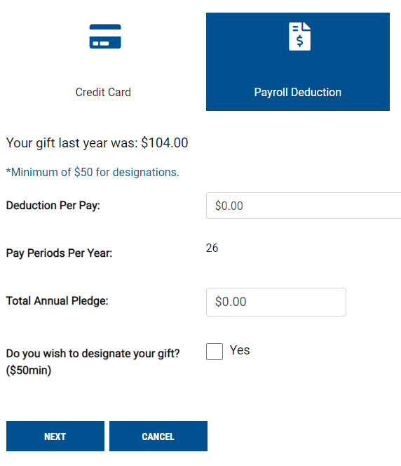

If you made a gift last year, it will appear here.

Select Yes to designate your gift.

- VERIFICATION
This page includes checkboxes to be acknowledged for sign-up for United Way affinity groups, receive a confirmation e-mail, and remain anonymous (donors name will not be published in the Annual Report).
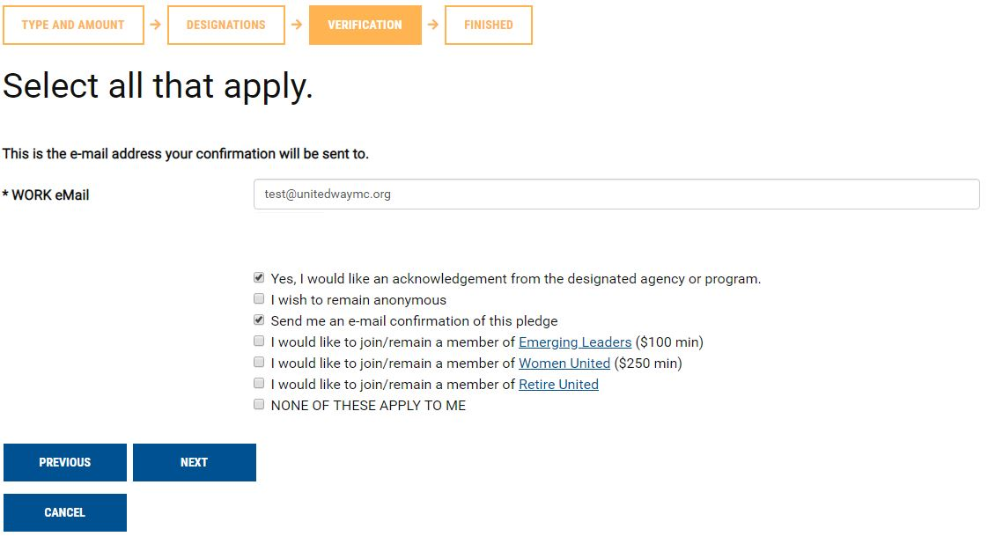

- VERIFICATION CONTINUED
A second verification page allows the donor to review and confirm their pledge details. The donor can go back to edit any details or click Confirm to complete their pledge.
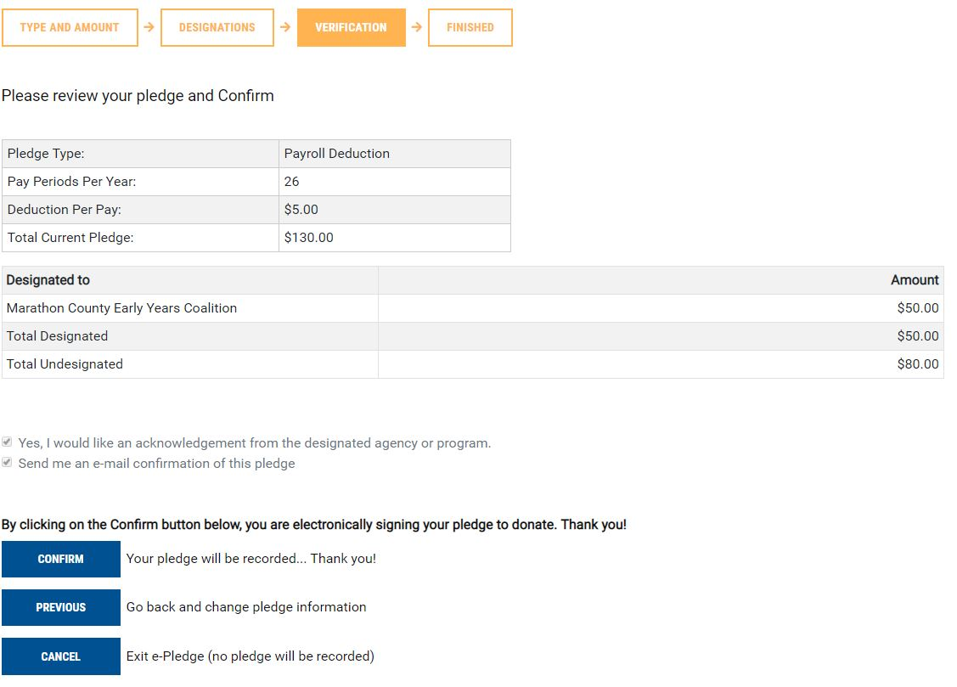

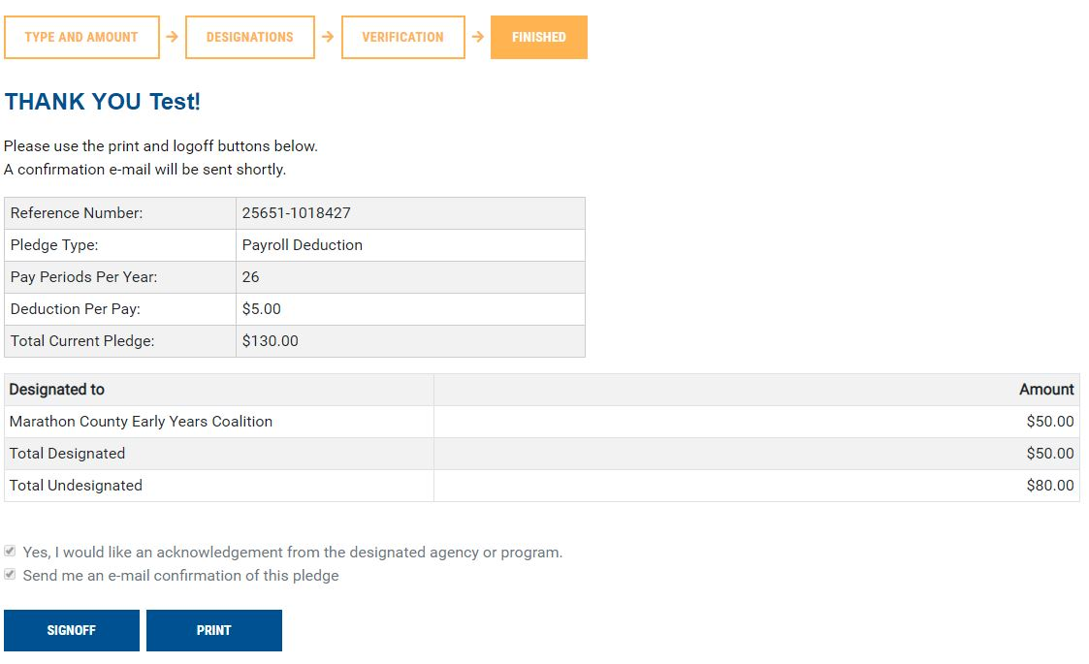
- COMPLETED PLEDGE:
Upon submission, the donor will be directed to the confirmation page that they may print for their records. They will also receive a personalized thank you e-mail with the details of their pledge.

ADMINISTRATOR:
Monitor your company campaign, run reports, enter and update pledges.
ADMINISTRATOR MENU
Allows you to see campaign results and run reports for your team.

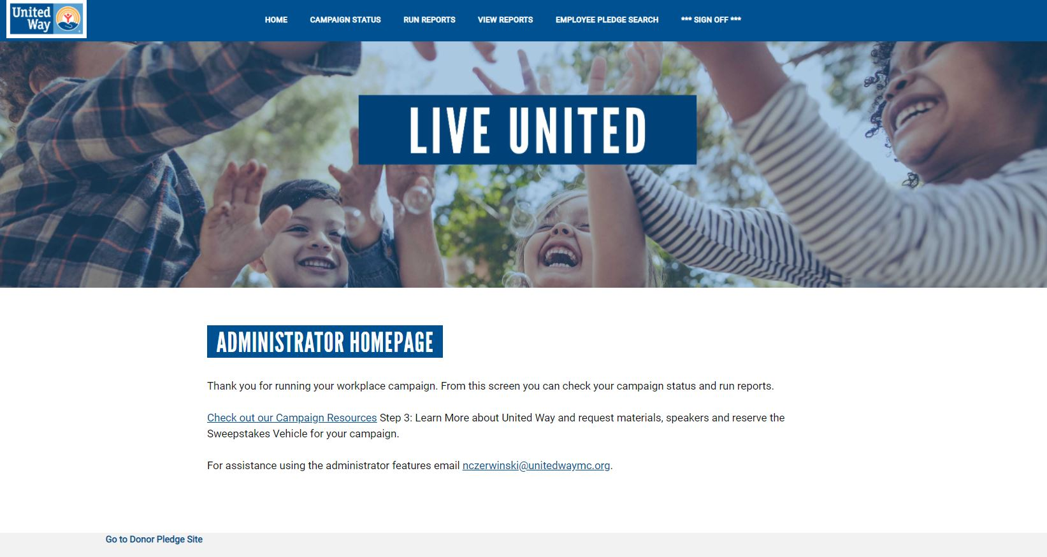
GO TO DONOR PLEDGE SITE
Switches you back to the DONOR Main Menu.

Things you can do from this screen:
CAMPAIGN STATUS: Allows you to see your company campaign progress (page 10).
NO RESPONSE: Allows you to run a report of those who have not yet pledged (page 11). To view reports you must click on VIEW REPORTS.
TRANSACTION REPORT: See who has completed their pledge (page 12).
To view reports you must click on VIEW REPORTS.
VIEW REPORTS: Allows you to view the reports you have generated (page 13).
EMPLOYEE PLEDGE SEARCH: Enter, update and delete employee pledges (page 14).
Ready to return to your Donor menu? Click GO TO DONOR PLEDGE SITE at the bottom of the page to switch back to the donor site.

CAMPAIGN STATUS:
Allows you to see your company campaign progress.
# of Employees & # of Donors.
Total dollars raised.
ed.
# of Responses includes all donors and those who indicated NO GIFT.

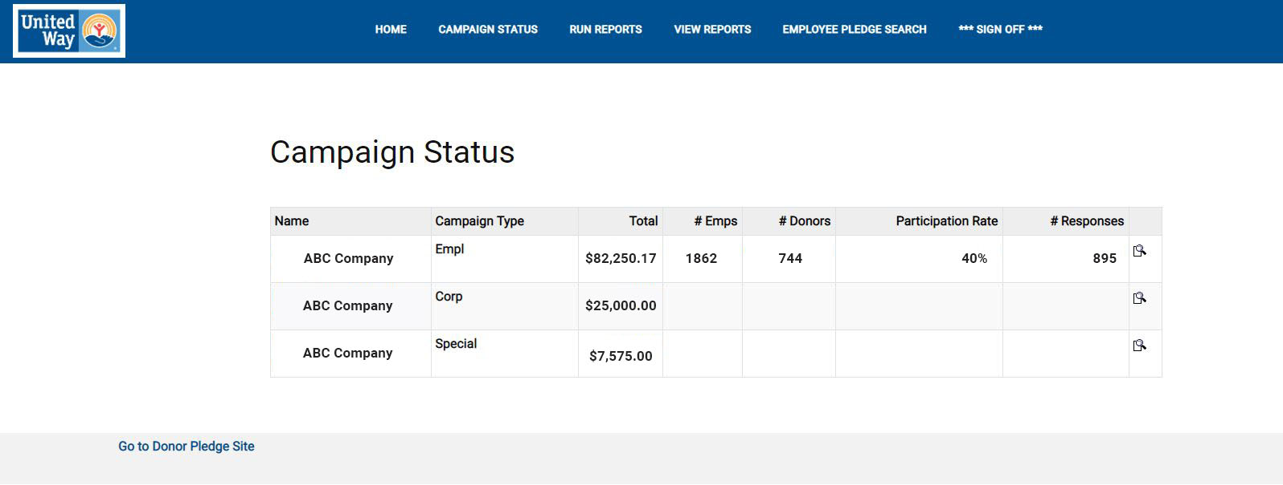

If your company has multiple locations this box will appear. Click ALL LOCATIONS to display the company total.

NO RESPONSE:
Generate a report of individuals who have not yet pledged. To view this report you must click on VIEW REPORTS.
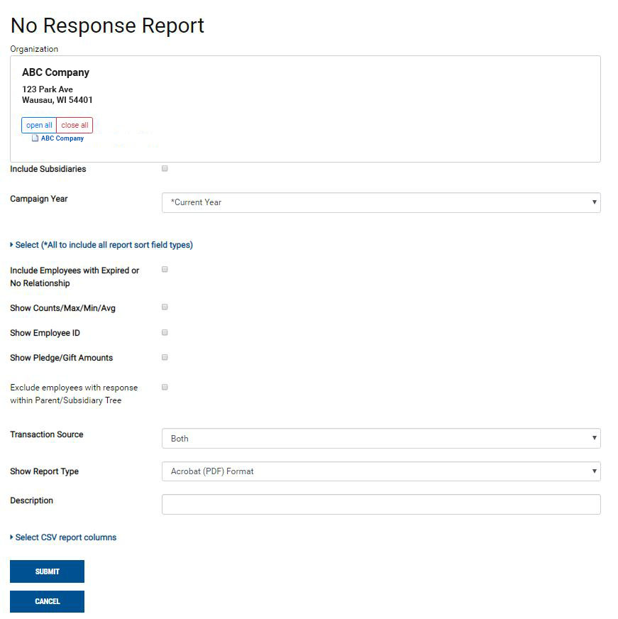
Under “Show Report Type” choose whether you would like the report as a PDF or CSV file.
To run this report click SUBMIT.

TRANSACTION REPORT:
Generate a report of individuals who have pledged. To view this report you must click on VIEW REPORTS.
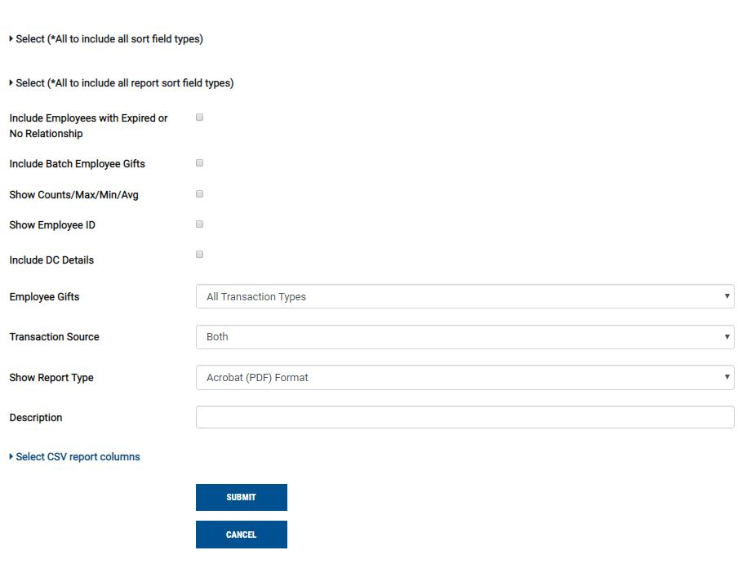
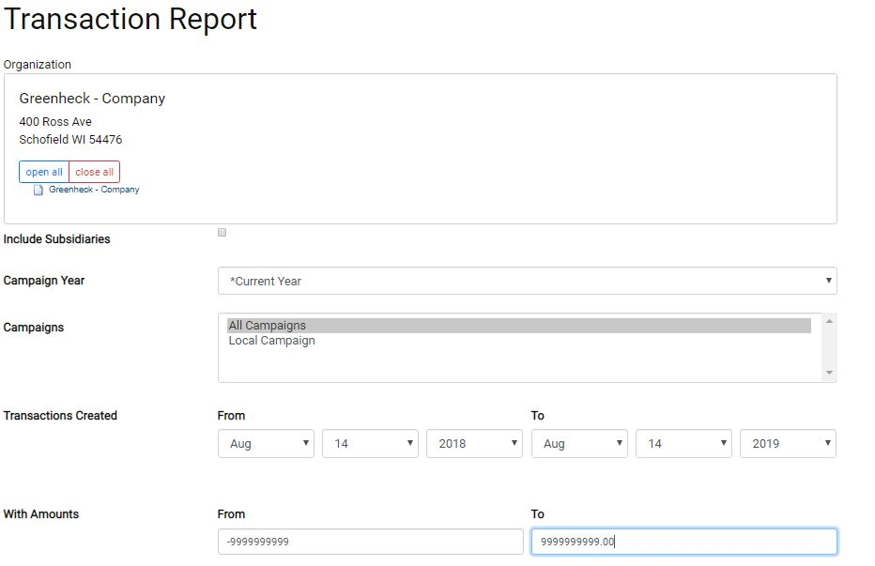
2020
2019
123 Park Ave
Wausau, WI 54401
ABC Company

Under “Show Report Type” choose whether you would like the report as a PDF or CSV file.

To run this report click SUBMIT.

VIEW REPORTS:
View your generated reports.
Your reports will appear here.
Click on the name of the report to open it.
If the Status is not “Ready”, the report is still generating.
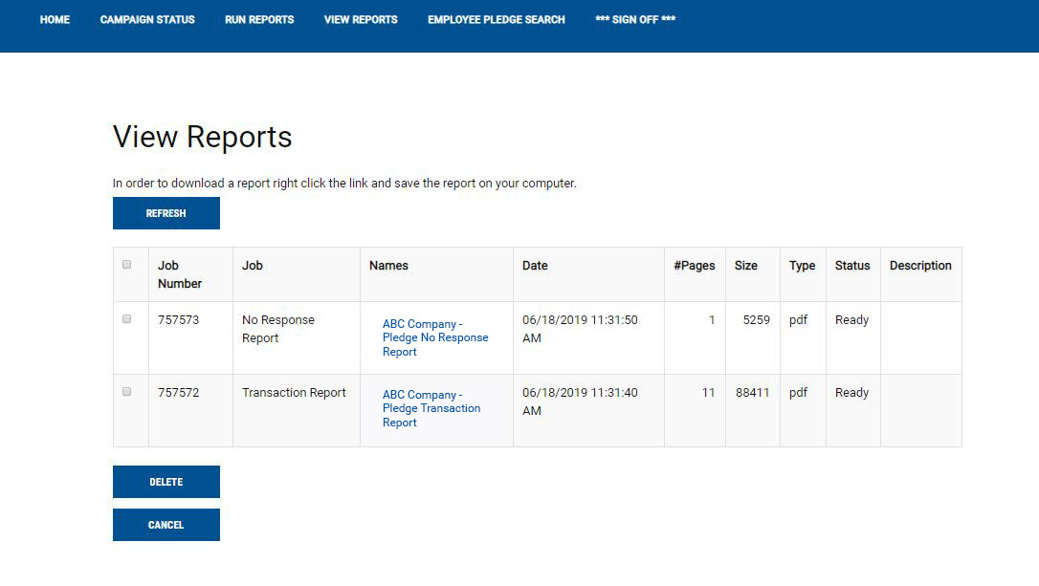
To delete a report check the box to the left of the report. Then click the DELETE button.
SAMPLE REPORT:
The names of individuals on your report will appear in the Employee Name column.
Name of the report will appear at the top of each page.
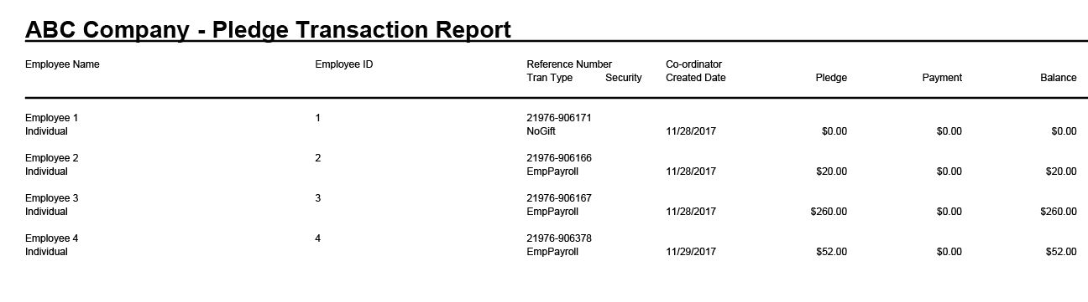

EMPLOYEE PLEDGE SEARCH:
On this page, you can search for an employee’s pledge, enter in paper pledges, update pledges, delete transactions, resend confirmation e-mails and add new employees. To enter in an employee pledge look up the employee using their Name or Employee ID in the search box.
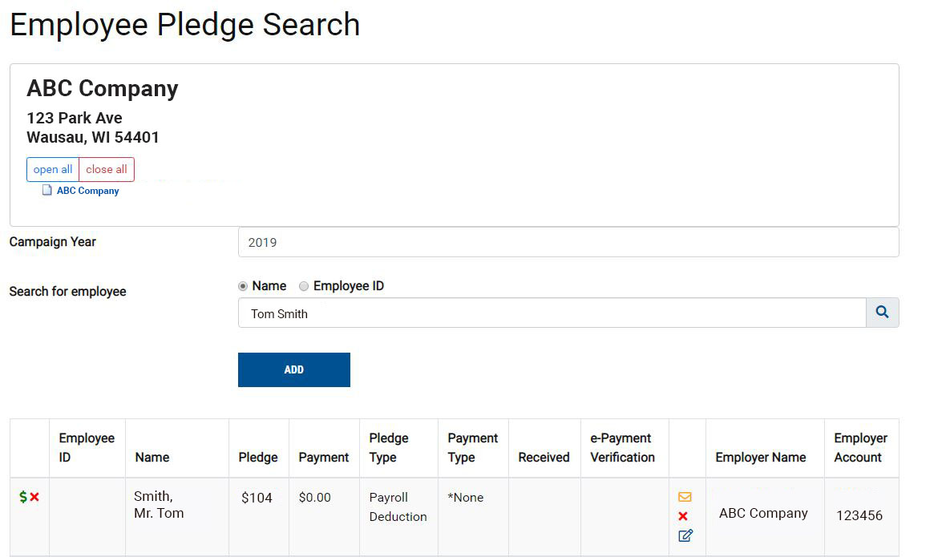
Add new employee.
Click on the $ to add an employee pledge.
Click on the X to delete an employee.
Click on the Pen and Paper Icon to Update a Pledge.
Type in the Employee name or Employee ID then click the search icon to the right.
Click on the mail icon to send a Confirmation
e-mail to an Employee.
Click on the X to Delete a Transaction.

Frequently Asked Questions
Will our information be shared?
No. Per our privacy policy (https://www.unitedwaymc.org/privacy-policy), we do not sell or share your company or donor information.
How will United Way use employee e-mail addresses once the campaign is over?
United Way will send a monthly e-newsletter to employees who donate to United Way. The
e-mail newsletter informs donors how their donations are working year-round. The newsletter will not be sent to employees who do not donate to United Way.
What if someone loses or deletes their link?
Someone who loses or deletes their link or has difficulty signing in should contact ePledge Support at 715-298-5711 or help@unitedwaymc.org, for immediate assistance.

What if some employees have no e-mail address or easy access to the web site?
Everyone can be set up for ePledge, regardless of whether they regularly use a computer at work. If there are large numbers of employees that absolutely do not have access, you may want to consider a mixed campaign where those without computer access can continue to submit paper pledge forms. If employees do not have a work e-mail or want a different method of logging onto the pledge site, we can set up User ID’s and Password. For example: The User ID could be the employee’s first and last name and their password could be their employee ID.
What about employees hired after we send you the data file? Can they use ePledge?
A new employee can be easily set up for ePledge at any time. Simply send the name, e-mail address and all other pertinent information to your United Way representative. The new employee will be set up and personalized link will be sent.
Can we use ePledge if we have multiple locations or a national campaign?
Yes. We will need more time for the set-up, but talk to your United Way representative.
Can I enter special events or corporate gifts in ePledge?
No. ePledge is a portal for employee donations only. Instead, put these gifts, including any paper pledge cards, in a campaign report envelope. Call your United Way representative at 715-848-2927 to get a report envelope. Complete the front of the envelope and contact your United Way representative when it is ready to be picked up.
Does the employee’s link expire after the campaign ends?
The campaign is finalized and turned off at your request. At that time, each employee’s personalized link is expired.
How will paper pledges be handled after the ePledge site is turned off?
Company coordinators should collect and forward all paper pledge forms to their United Way representative as quickly as possible. All paper pledge forms will be entered into our processing system by United Way staff.
This is our first year to use ePledge. What are the best ways to promote this change to our employees?
It is important that you inform your employees that you are using ePledge. Take time at your employee campaign meetings to highlight the ePledge giving portal and explain what they can expect and how to use it.

