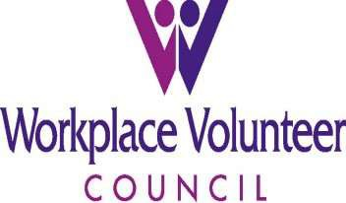
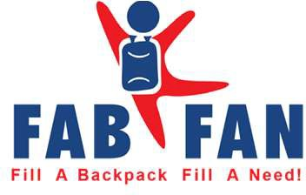
2023 THANK YOU!
Grant Provided By
B.A. & Esther Greenheck Foundation
Facility Sponsor
Central Wisconsin Convention & Expo Center
Gold Sponsors $2,000+
May Family Foundation Walter Alexander Foundation
Raymond & Marie Goldbach Foundation
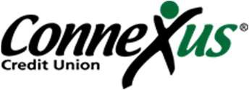
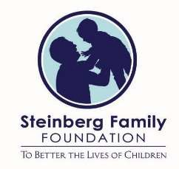
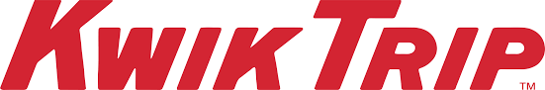
SILVER SPONSOR $1,000-$1,999
UnitedHealthcare Chr. Hansen
CoVantage Credit Union
Green Bay Packaging ~ Vending Machine Fund
Imperial Industries
Bronze Sponsors $500-$999
Be Amazing
Dan Storey Foundation Everest Area Optimist
First Universalist Unitarian Church of Wausau Gary Treu Trust
Victor & Helen Geisel Foundation Wausau Breakfast Optimist Club Trailmates/Taste N Glow Balloon Fest, Knights of Columbus Council 1069- Jon Kleist
Chr. Hanson, Inc./Jacki Nylund –
Coldwell Banker Action Gift Fund –Kris Rybarczk
Gary Treu Trust - Dean Dietrich
Mark & Ann Bradley Fund
CGI Technologies and Solutions
(in recognition of Marathon Cheese employees volunteering at Balloon Fest)

In-kind Donors
County Market; Crystal Finishing Systems, Inc.; Festival Foods; Industrial Repair Service of Wausau;
J & D Tube Benders, Inc.; Kohl’s; KPS Tool & Die Inc., Kreger’s Bakery; Noodles & Company; Polito’s Pizza; Sam’s Club; Sterling Water Culligan; United Way of Marathon County; and WOW Logistics
Public Collection Locations
AbbyBank, Cloverbelt Credit Union, Health in Motion, Innovative Health, J & D Tube Benders, Inc., Peoples State Bank, and Prevail Bank, Marathon Cheese Corporate Office

P.O. Box 1384, Wausau, WI 54402-1384
workplacevolunteercouncilmc@gmail.com

Like and share
Marathon County Fill A Backpack Fill A Need

In Marathon County, there are over 7,500 students who are *eligible to receive a new, FREE, backpack and common school supplies for the upcoming school year through the Workplace Volunteer Council’s (WVC) signature project – Fill A Backpack Fill A Need (FABFAN). To be
*Eligible to take part in FABFAN, students must be entering 4K through 8th grade and qualify for free or reduced lunch at school.

Getting ready for FABFAN is a year-round effort! To make it happen, we need ongoing support from our community members, businesses, organizations, and schools – donors, sponsors, collection drive hosts, and volunteers. We need YOU!
How can you help?
- Donate supplies. New backpacks and school supplies can be delivered to any of FABFAN’s Public Collection Sites: AbbyBank, Cloverbelt Credit Union-all 3 locations, Health in Motion, J & D Tube Benders, Inc., Marathon Cheese Retail Store, Merrill Steel, Peoples State Bank, WAOW, and Wausau Times/Buyers' Guide.

- Make a monetary donation. We “s-t-r-e-t-c-h” each dollar that is donated. We shop the clearance sales at local stores. We buy in bulk to secure the best prices on the significant quantities of supplies that are needed each year.
- Be a FABFAN sponsor. Three sponsorship levels are available. Each level provides an opportunity for you or your business to be recognized for all materials that are produced. If you choose to be a Gold-level sponsor, your logo will also be included.

Gold Sponsor | Silver Sponsor | Bronze Sponsor
$2,000+ donation | $1,000-$1,999 donation | $500-$999 donation

The WVC is coordinating with participating schools to pick up their FABFAN supplies. The schools will then distribute FABFAN supplies to their participating students. Schools are currently working on their distribution plans and will update families when finalized.
Imper
Here are some of the schools and organizations we help: Abbotsford School District, Athens Elementary & Middle School, Boys & Girls Club, Children’s Wisconsin – Wausau office, Colby School District, D.C. Everest Area Schools, Edgar School District, Faith Christian Academy, Marathon School District, Marathon County Social Services, Mosinee School District, Rosholt School District, Newman Catholic Middle School, Salvation Army’s “Tools for School” Program, School District of Spencer, St. Anthony de Padua Catholic School (Athens), St. John the Baptist Catholic School (Edgar), St. Mary’s School (Marathon), St. Mary's Catholic School (Colby), Stratford School District, The Women’s Community, Wausau School District, and Wittenberg-Birnamwood School District

Dean Dietrich
We all know that a bright future starts with a good education. Let's help our children start the school year with the supplies they need to be successful. We cannot do this without you!

Sincerely,
Workplace Volunteer Council

Janet Felch
WVC President and Treasurer

Fill-A-Backpack Fill-A-Need Committee
The Workplace Volunteer Council is a partner project of the United Way of Marathon County with the council directing its own projects. The United Way serves as the non-profit fiscal sponsor of the Workplace Volunteer Council. The Workplace Volunteer Council has 501(c)3 non-profit status through them.

